Milano, 5 novembre 2012
Ore 14-16
Dipartimento di Elettronica e Informazione del Politecnico di Milano
Via Ponzio 34/5
AULA SEMINARI

Seminario
(IN LINGUA INGLESE)
Mobiles for Museums

Nancy Proctor, Head of Mobile Strategy and Initiatives Smithsonian Institution

Abstract
Recruiting the World: So how's that going for you?

The vision for mobile at the Smithsonian is to use the powerful, network-connected devices that are now nearly ubiquitous to "recruit the world" to help the Institution achieve its mission of the increase and diffusion of knowledge. This may sound like an absurdly ambitious aim, but in fact the Smithsonian has been "crowdsourcing" - avant la lettre - since its first secretary, Joseph Henry, used the new technology of his day, the telegraph, to crowdsource the first national weather map. He was followed by Secretary Baird who worked with citizen scientists to develop the Institution's natural history collections. Even today we have more volunteers than paid staff at the Smithsonian.
A number of mobile projects at the Smithsonian have already proven the value of moving "from headphones to microphones" - to collaborative learning models in which we ask questions, listen to the wisdom of the crowd and partner with our publics to accomplish tasks that would be impossible with just our staff and internal resources. But such participatory projects are new to museums and the cultural sphere: there are few precedents or benchmarks that can help us measure how we are doing against the goal of "recruiting the world." Nonetheless, powerful examples are available for further research and inspiration, ranging from Wikipedia to Galaxy Zoo and social tagging of museums' digital collections.

This workshop will ask - and begin to look at ways of answering – how we measure the success of crowd sourcing in the Smithsonian's mobile projects and beyond.

About the workshop leader
Nancy Proctor is co-chair of Museums and the Web. With a PhD in American art history, she began publishing online exhibitions in 1995 with Titus Bicknell at TheGalleryChannel.com. TheGalleryChannel was acquired by Antenna Audio, where Nancy led New Product Development from 2000-2008. From 2008-2010 she was Head of New Media Initiatives at the Smithsonian American Art Museum, and since 2010 leads Mobile Strategy and Initiatives across the Smithsonian. Nancy served as program chair for the Museums Computer Network (MCN) conference 2010-2011, co-organized the 2008-2010 Tate Handheld conferences, manages the MuseumMobile.info wiki and is Digital Editor of Curator: The Museum Journal.

INDICAZIONI PER RAGGIUNGERE LA SALA SEMINARI DEL DEI
Automobile: Tangenziale Est (Uscita Lambrate)
Treno: Stazione FS Lambrate
Metro: Fermata MM2 Piola / MM2 Lambrate
Tram: Fermata Bassini/Ponzio n. 11 o n. 23

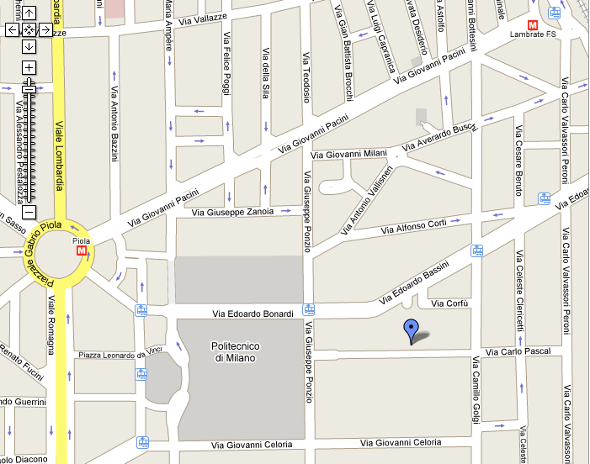
Dipartimento Elettronica e Informazione

